Title: | <Door Control Module>  SW Component < ADC >

History
Issue status  (Index) | Maturity/Date  (draft/invalid/valid)  (dd-mmm-yyyy) | Author  Department | Check/Release  Department | Description
1.0 | Draft  04-0ct-20 | Miguel Garcia | Miguel Garcia | Creation of the document

Table of Contents
1 Purpose 3
2 Definitions and abbreviations 3
3 Realization constraints and targets 3
4 SW Conceptual design 3
5 SW Component internal breakdown 4
5.1 Functional Decomposition 4
5.2 Function <Type> <function name> (type par 1, .., type par n) 5
5.3 Function <Type> <function name> (type par 1, .., type par n) 5

Purpose
This software component from microcontroller layer used to provide measured values from analog signals

Definitions and abbreviations
Definitions
Special Byte  ADC | Special byte received to change the baud rate 55h  Analog-Digital Converter

Abbreviations
Only SW Component specific abbreviations.
References
N° | Document name | Reference
1  2  3 | Door Control Module.doc  SWA_DCU.rpyx  Traceability Matrix Template.xlsx

Realization constraints and targets
Convert analog signals those received from AntiPinch system. The system shall have 10 bits of resolution. The system will read analog ports periodically while the car is running on.

SW Conceptual design
The AntPinch system will report an antipinch event using a 10 bits resolution analog input. The system shall detect AntiPinch event if the analog signal transitions from below the threshold to above the threshold using 820 ADC count as threshold reference. ADC system shall initialize itself as first step, and will read the analog ports periodically while the car is running on.

SW Component internal breakdown
ADC SW component is composed of 3 main functions, one of them return unsigned integers of 16 bits, and the rest are actuation processes.
- ADC_Init
- ADC_Run
- ADC_Get_AntiPinch_Value

DATA TYPES
uint_16 adc_value

Functional Decomposition
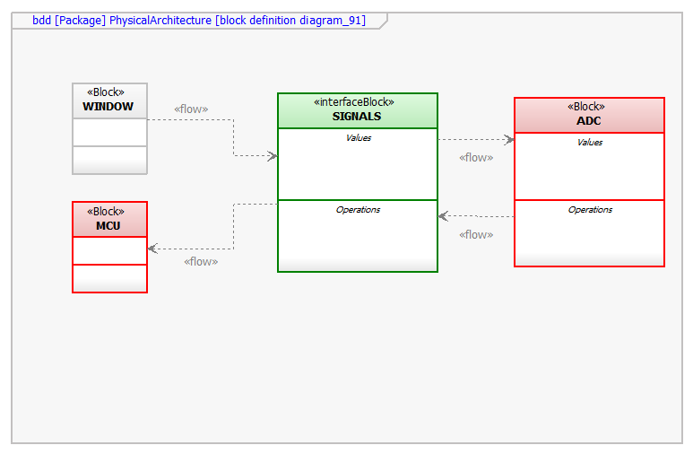
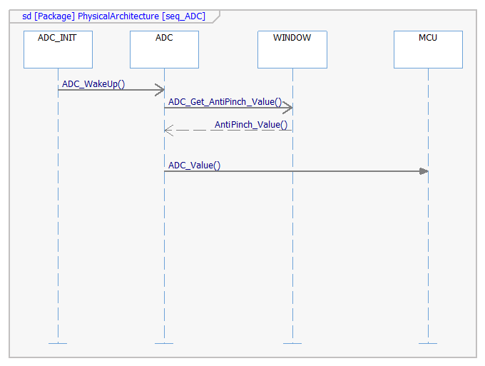
Function Description and Dynamic Behavior
SWC from EcuAbstraction layer responsible to implement all the services to control the Window on the ECU.
- It is responsible to attend request from application to operate window control operations.
- It is also responsible to determine and provide window status to Application.
- It also implements Antipinch functionality.

The system will receive analog signal from WINDOW (antipinch), the interface SIGNALS process and send the information to ADC function. ADC function convert the analog value to a digital signal value, after that this value will return to SIGNALS, this interface sends the digital value from adc to MCU.

Function uint_16 ADC_GET_ANTIPINCH_VALUE ()
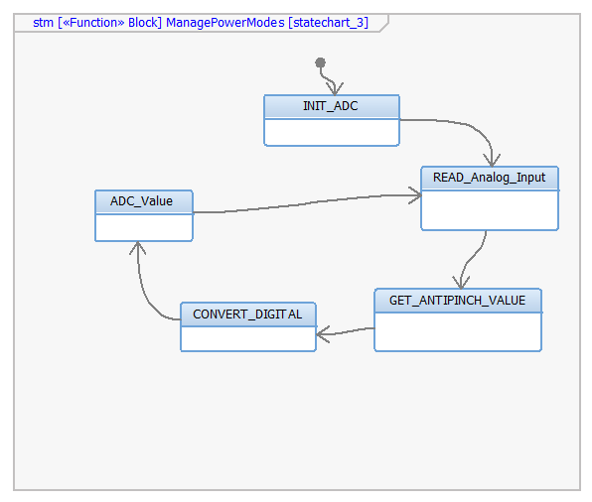

Description | Adc Interface to report measured value of the AntiPinch signal.
Return Value | Returns the analog ADC antipinch value (16 bits unsigned integer)
Precondition | Antipinch should detect a value from analog input
Post condition | Antipinch return digital analog signal
Error Conditions | Antipinch detects a negative value
Requirements | DCU_SWC_108

Dynamic Behavior
uint_16 AnalogSignal=ADC_GET_ANTIPINCH_VALUE();
if ADC_GET_ANTIPINCH_VALUE()= 0x2AH4
AnalogSignal=0x2AH4

Function void ADC_Init ()
Description | Interface function to perform ADC software component initialization
Return Value | No value to return
Precondition | ADC is not initialized before
Post condition | ADC initialized
Error Conditions | Some dependent configuration is not initialized before
Requirements | DCU_SWC_108

Dynamic Behavior
the system will initialized the ADC system, so this component will execute just once to wake up ADC.

Function void ADC_Run ()
Description | Interface to perform ADC software periodic Operations
Return Value | No value to return
Precondition | ADC is initialized
Post condition | ADC make periodic operations
Error Conditions | ADC_Init not executed before
Requirements | DCU_SWC_108

Dynamic Behavior
The system will execute periodic operations to perform constant digital’s values from analog inputs.

